**How to Store a plain text document and retrieve a document?**

I am going to use [express framework](http://codeforgeek.com/2014/10/top-5-node-packages/) and middleware called **“multer”.**This middleware is designed for handling the multipart/form-data.

In front-end script, we will set the **“target”**parameter of **FORM**to our router. for.eg  **/upload/text**and in **app.get(‘/upload/text’, …)**we will be able to handle our file.

**Project:**

We will have simple express web server which does the task of routing

and other stuff. **Multer**will take care of the file handling and HTML for handling form input.

**package.json**

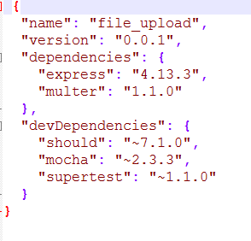

**Installing dependency:**

Save the package.json in folder and type

npm install

to install the required stuff.

This code is updated with latest version of Multer.

**Server.js**

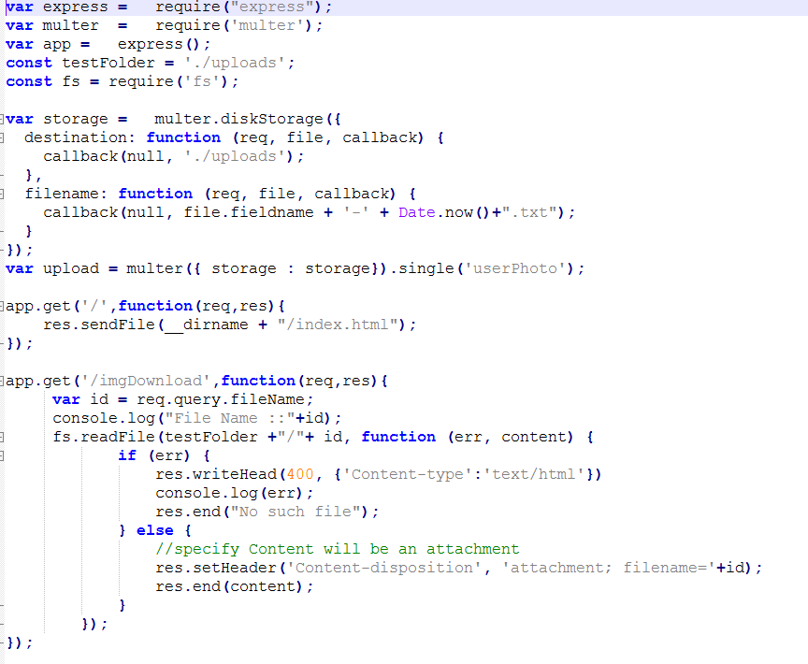

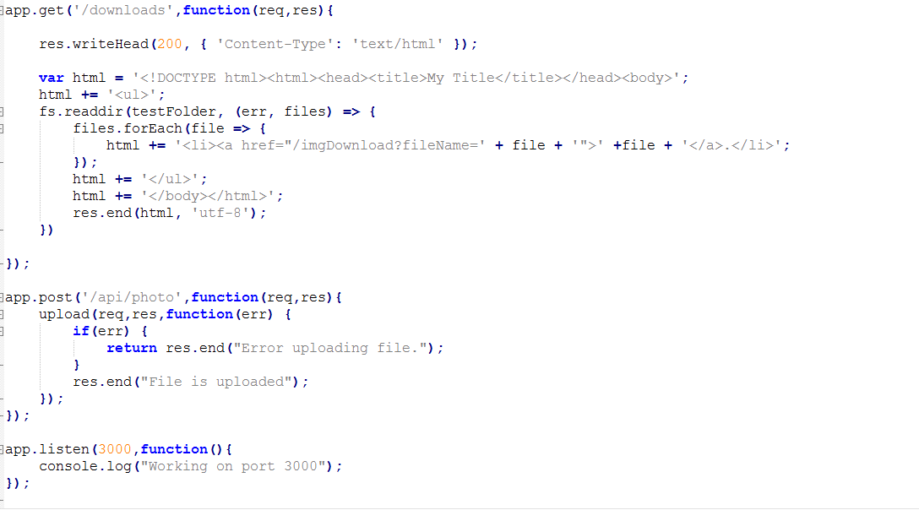

**How to test this project:**

1. Download the file ‘Filemaster.rar’ and extract it and save to a directory(Let’s say ‘Fileupload’ on your desktop) on your computer

2. Open the command prompt in your computer and go to above directory. Please find below



3.Then enter “node <source code filename>.js “ in my case it is “node Server.js” .

Then you will get “Working on port 3000” . PFB



4.Then open any browser and type “localhost:3000”

Copy code from and save them in folder. Type

node Server.js

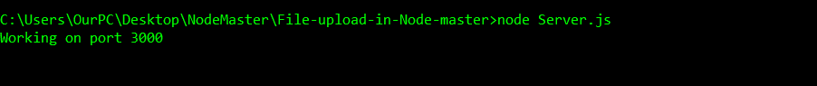

to run the project. Visit **localhost:3000** to view the app. Select the file and check the **uploads** folder. Your file must be present there!

